Panasonic Industry Europe presents the NPM-VF insertion machine for new levels of flexibility
The evolution of true odd-form component insertion and SMT placement machine
Munich, July 2020
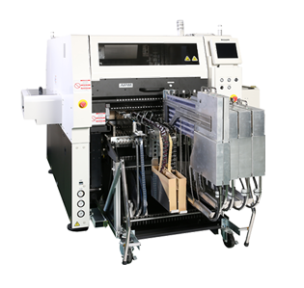
Panasonic Factory Solutions, a division of Panasonic Industry Europe, presents the evolution of the NPM-VF, a true odd-form component insertion machine. It evolved from decades of know-how in THT and SMT placement technology.
The dual-gantry, multi-head, odd-form placement and insertion machine has been constantly improved to provide new levels of flexibility within the production environment. With its various configurations of head tools and machine feeder possibilities the placement of odd-shape components is highly effective. This increases quality, output and ultimately reduces manpower at the production line.
The NPM-VF achieves a high-speed throughput of up to 4.500cph, with component sizes ranging from 5x5mm up to 130x35mm and 60mm in height. The integrated body chuck is designed to grip large, odd-form components without a pick surface and through-hole components are handled by the lead chuck. Standard options for highest insertion flexibility are the active cut and clinch function and high insertion forces of 100N-150N. With its flexible feeder configuration components can be provided by feeder cart, single tray or double tray feeder. Along with the standard SMT intelligent tape feeders various component feeding types are possible: tray feeder, stick feeder, radial and axial tape feeder and bowl feeder. Also the loading of components is possible during the operation of the NPM-VF, so downtime due to component exhaust is eliminated.

Of course the NPM-VF can be integrated into a connected production environment with the line manager software iLNB and can be managed by PanaCIM Gen2. High-level software features, such as auditable verification, plant-wide total traceability, automatic changeover and material tracking are available to further increase the quality and productivity of the manufacturing process.
Building on from the solid NPM SMT platform, the NPM-VF offers flexibility and customizable options to address your production needs extending the possibilities of automatization in your manufacturing.
Further information about Panasonic Factory Solutions can be found here.

__________
About Panasonic
Panasonic Corporation is a worldwide leader in the development of diverse electronics technologies and solutions for customers in the consumer electronics, housing, automotive, and B2B businesses. The company, which celebrated its 100th anniversary in 2018, has expanded globally and now operates 582 subsidiaries and 87 associated companies worldwide, recording consolidated net sales of US$72.10 billion for the year ended March 31, 2019. Committed to pursuing new value through innovation across divisional lines, the company uses its technologies to create a better life and a better world for its customers.
To learn more about Panasonic: http://www.panasonic.com/global

About Panasonic Industry Europe
Panasonic Industry Europe GmbH is part of the global Panasonic Group and provides automotive and industrial products and services in Europe. As a partner for the industrial sector, Panasonic researches, develops, manufactures and supplies technologies that support the slogan “A Better Life, A Better World”.
The company’s portfolio covers key electronic components, devices and modules up to complete solutions and production equipment for manufacturing lines across a broad range of industries. Panasonic Industry Europe is part of the global company Panasonic Industrial Solutions.
More about Panasonic Industry Europe: http://industry.panasonic.eu

