A Fresh Idea for Cleanest Air
Panasonic Industry introduces small size laser sensor to effectively detect floating particle in the air
Munich, SEPTEMBER 2020
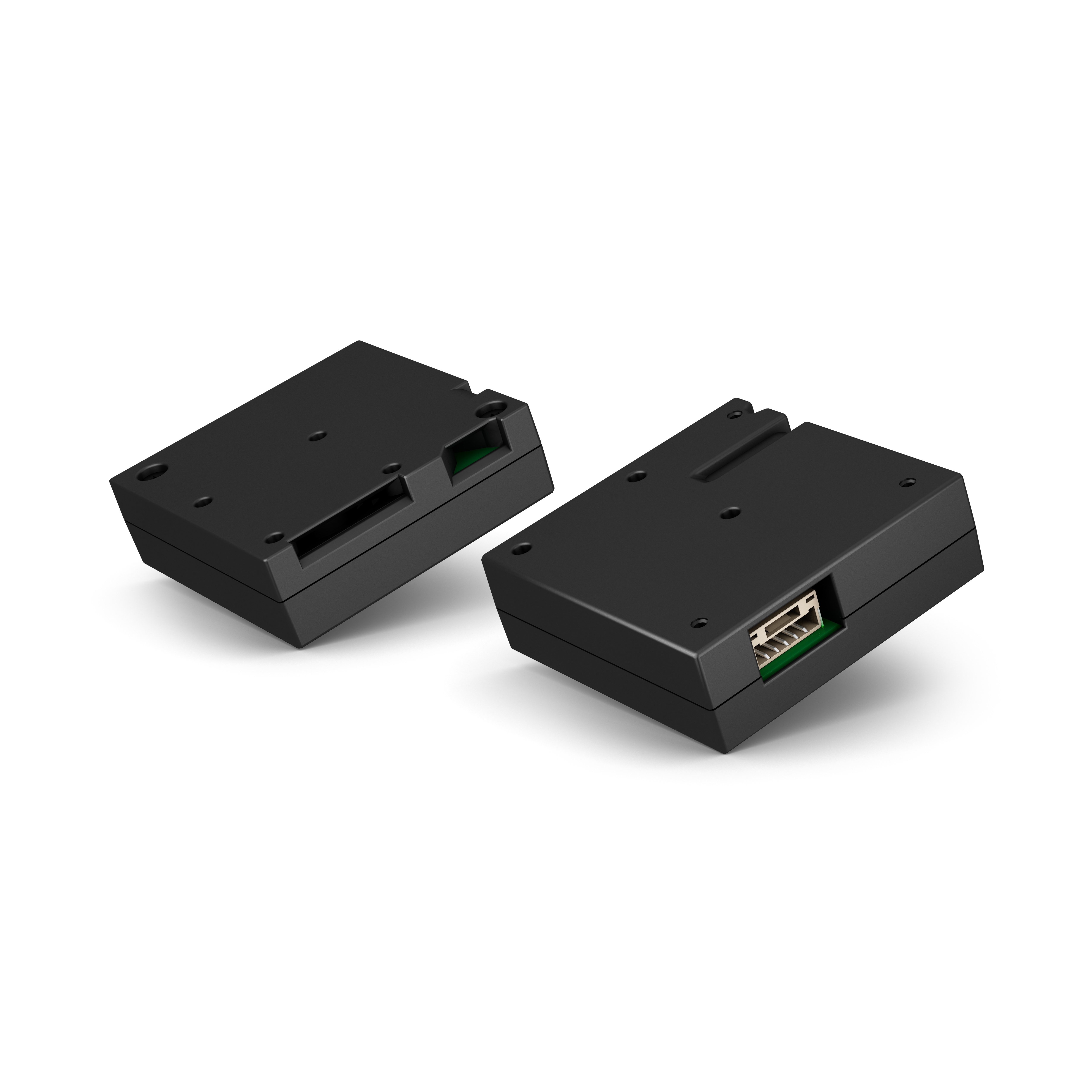
Wherever we live, wherever we work - it is first and foremost the quality of the air we breathe that makes the most decisive difference for our everyday wellbeing.

Now, Panasonic Industry presents Particulate Matters (PM) sensors that are reliably able to detect smoke, environmental dust and other unwanted dangerous pollutant in the air that surrounds us in our living rooms, working spaces or any other “insides” we spend our time in.
Based on laser scattering technology, the sensors guarantee accurate PM2.5, PM10 & PM1 detection and thus qualifies for efficiently protecting the human organism from straining ultra-fine particulates.

“Thanks to its remarkably small dimensions of only 37x37x12mm, optimized air pathway structure and real time as well as high accurate measurement throughout its proven long lifetime”, as Dr. Sara Ghaemi, Team Leader IoT at Panasonic Industry Europe summarizes, “Panasonic Industry PM sensor is an ideal choice for a wide range of air quality monitoring devices - and clearly surpasses LED-based concepts in many regards.”

Indeed, the laser type PM sensors fit numerous systems safeguarding the level of air pureness – from HVAC systems in the context of smart home or building automation to environmental air control stations or even IoT devices.

“Fine and ultra-fine particulates are ubiquitous in our bustling environments and dangerous for our health. Humans are incapable to detect the continuous changes in the air quality”, concludes Dr. Sara Ghaemi. “Hence Panasonic SN-GCJA5 enables the implementation of required air quality monitoring devices to improve the surrounding air quality by smart activation of air purification equipment.”

For more information, please visit:

https://industrial.panasonic.com/ww/products/sensors/built-in-sensors/dust-sensor/pm_laser

__________
About Panasonic
Panasonic Corporation is a global leader developing innovative technologies and solutions for wide-ranging applications in the consumer electronics, housing, automotive, and B2B sectors. The company, which celebrated its 100th anniversary in 2018, operates 528 subsidiaries and 72 associated companies worldwide and reported consolidated net sales of 61.9 billion Euro (7.49 trillion yen) for the year ended March 31, 2020. Committed to pursuing new value through collaborative innovation, the company uses its technologies to create a better life and a better world for customers.
To learn more about Panasonic: http://www.panasonic.com/global

About Panasonic Industry Europe
Panasonic Industry Europe GmbH is part of the global Panasonic Group and provides automotive and industrial products and services in Europe. As a partner for the industrial sector, Panasonic researches, develops, manufactures and supplies technologies that support the slogan “A Better Life, A Better World”.
The company’s portfolio covers key electronic components, devices and modules up to complete solutions and production equipment for manufacturing lines across a broad range of industries. Panasonic Industry Europe is part of the global company Panasonic Industrial Solutions.
More about Panasonic Industry Europe: http://industry.panasonic.eu

