High capacity switching for next-gen automotive technology
With the new 60A-rated TT series, Panasonic Industry meets the increasing demand for PCB-based miniaturized relays in the context of modern automotive applications
Munich, OCTOBER 2020
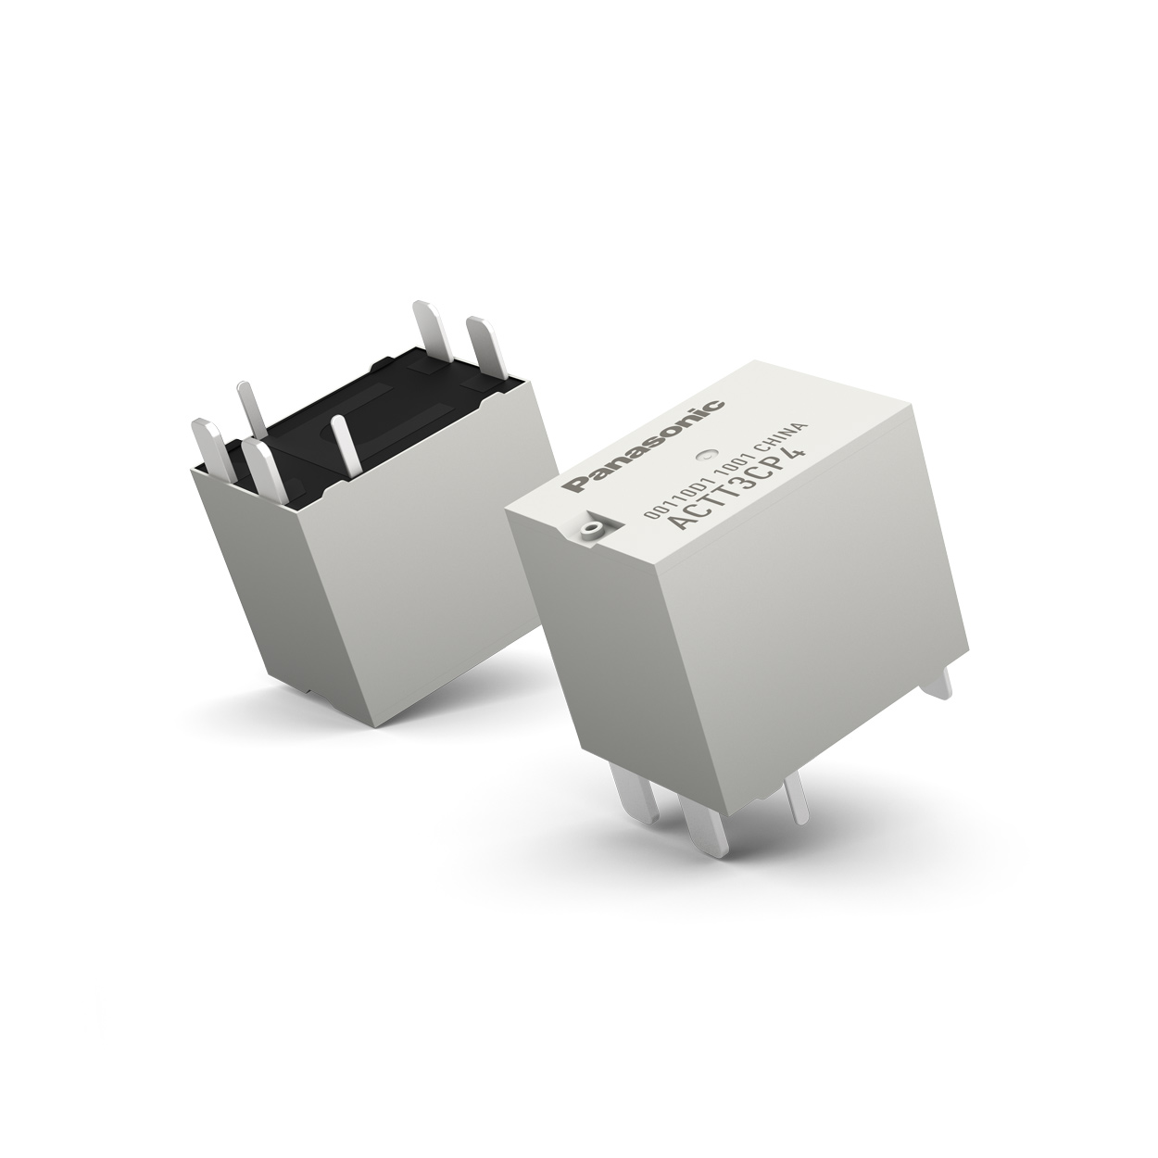
When it comes to switching solutions, contemporary automotive application design resorts more and more to PCB mounted products. The primacy of miniaturization and efficiency without compromises in terms of reliability and performance render THT or PiP mounted relays a perfect solution for multiple high current loads.

The high capacity TT series – supporting 60A @14VDC with a double make 2 Form A (1 Form U) contact configuration – is tailored to smart junction boxes that come to use in applications throughout the vehicle.
“Those state-of-the-art junction boxes”, as Michael Immle from Panasonic Industry Europe summarizes, “are a downright leap in terms of switching structure: The overall ratio of relays employed is currently increasing significantly – as well as the overall share of PCB-mounted relays.”

Coming in miniaturized housings 17.8 x 13 x 16 mm, TT relay series is expected to save between 15% to 29% board space in comparison to similar products.
With available heat-resistant (110°C) or pin in paste soldering compatible types, the TT series of Panasonic Industry is now a first-choice product for high capacity switching in many car applications – such as defoggers, head lamps, seat heaters, fog lamps, fan motors and many others.

Learn more on the TT automotive relays series here.
https://industry.panasonic.eu/productfinder?series=TT+Relays&mode=FILTER_MODE

About Panasonic
Panasonic Corporation is a global leader developing innovative technologies and solutions for wide-ranging applications in the consumer electronics, housing, automotive, and B2B sectors. The company, which celebrated its 100th anniversary in 2018, operates 528 subsidiaries and 72 associated companies worldwide and reported consolidated net sales of 61.9 billion Euro (7.49 trillion yen) for the year ended March 31, 2020. Committed to pursuing new value through collaborative innovation, the company uses its technologies to create a better life and a better world for customers.
To learn more about Panasonic: http://www.panasonic.com/global

About Panasonic Industry Europe
Panasonic Industry Europe GmbH is part of the global Panasonic Group and provides automotive and industrial products and services in Europe. As a partner for the industrial sector, Panasonic researches, develops, manufactures and supplies technologies that support the slogan “A Better Life, A Better World”.
The company’s portfolio covers key electronic components, devices and modules up to complete solutions and production equipment for manufacturing lines across a broad range of industries. Panasonic Industry Europe is part of the global company Panasonic Industrial Solutions.
More about Panasonic Industry Europe: http://industry.panasonic.eu

