Handling heat the modern way
Panasonic Industry introduces new type of its Graphite Thermal Interface Material (TIM) for efficient thermal dissipation on power modules
Munich, DECEMBER 2020
Handling heat is a major challenge when operating power modules in demanding and even harsh industrial or automotive contexts.

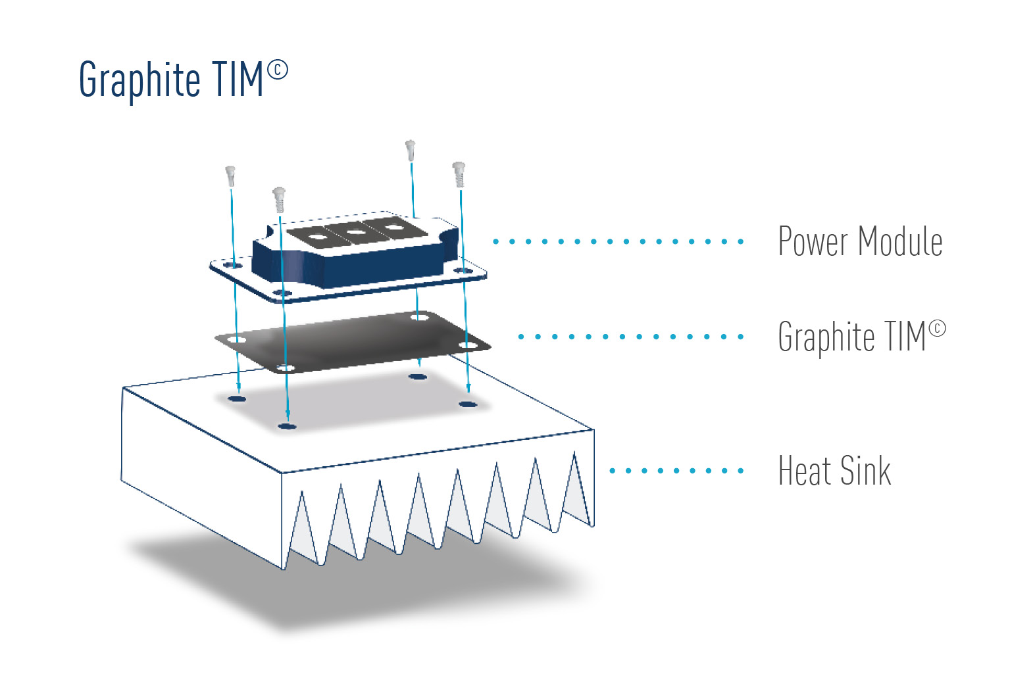
Mounted on dedicated heat sinks, heat dissipation is traditionally achieved with a particular layer of grease – that, of course, has to be replaced from time to time. A labor-intensive frequent task, next to the fact that grease naturally doesn’t stay only where it is applied. That, in turn, counteracts an effective thermal dissipation.

All these issues are addressed – and solved by Panasonic Industry’s GraphiteTIM. Now, the renowned manufacturer has released its highly compressible EYGR type, reducing the thermal resistance by filling the gap and the unevenness on the surface of both power module and heatsink, and thus enhancing the thermal dissipation performance.

With a thermal resistance of 0.2 K∙cm²/W (at 600 kPa) and a thermal conductivity in X-and Y- direction from 200 to 400 W/m∙K, respectively 28 W/m∙K in Z-direction, the Panasonic Industry GraphiteTIM types are a promising option for the reliable cooling by high heat transferring performance and wide operating temperature range from -55 to 400℃ for power module in many electronic devices:
Inverters, converters, automotive control units, medical equipment or server infrastructures will clearly profit from an increase in reliability, longevity and service easiness.

Learn more on the GraphiteTIM on our website or have a look in the brief introduction video

__________
About Panasonic
Panasonic Corporation is a global leader developing innovative technologies and solutions for wide-ranging applications in the consumer electronics, housing, automotive, and B2B sectors. The company, which celebrated its 100th anniversary in 2018, operates 528 subsidiaries and 72 associated companies worldwide and reported consolidated net sales of 61.9 billion Euro (7.49 trillion yen) for the year ended March 31, 2020. Committed to pursuing new value through collaborative innovation, the company uses its technologies to create a better life and a better world for customers.
To learn more about Panasonic: http://www.panasonic.com/global

About Panasonic Industry Europe
Panasonic Industry Europe GmbH is part of the global Panasonic Group and provides automotive and industrial products and services in Europe. As a partner for the industrial sector, Panasonic researches, develops, manufactures and supplies technologies that support the slogan “A Better Life, A Better World”.
The company’s portfolio covers key electronic components, devices and modules up to complete solutions and production equipment for manufacturing lines across a broad range of industries. Panasonic Industry Europe is part of the global company Panasonic Industrial Solutions.
More about Panasonic Industry Europe: http://industry.panasonic.eu

