Capacitance that lasts
Panasonic Industry introduces new V-FH long life type of its SMT Aluminum Electrolytic Capacitor range – coming with excellent temperature characteristics.
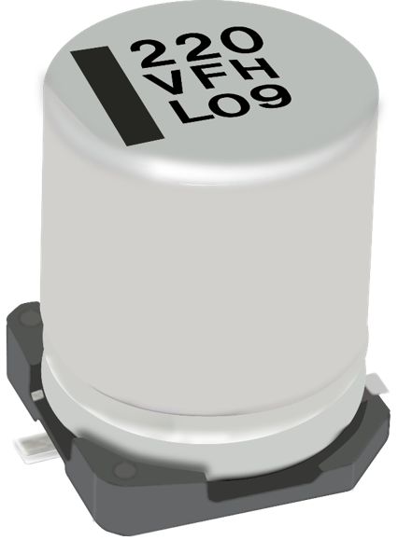
Munich, FEBRUARY 2021
Good performance features are only worth something if they last. Only then can there be any talk of reliability. So, the durability and life-cycle of an electronical component is vital for the reliability of an entire application – let it be a simple smart home device or an industrial application’s ower supply.

Introducing the new V-FH long life type capacitor of its SMT Aluminum Electrolytic series, Panasonic focused on the evolution of durability:
The series is comes with proven 10,000 hours at 105℃ (φ6×8：7000h 50V：7000h) and is currently available in 6.3~50VDC, 10~680µF.

Thus, it qualifies for employment in long-lasting applications – from smart lighting products, IT equipment and infotainment systems up to heavy industry contexts where a persistent performance is a prerequisite.

Next to a particularly low ESR and a high temperature reflow, the developers at Panasonic Industry had also environmental criteria in mind: The new series is RoHS compliant and available as Halogen-free version.

The new V-FH caps are certainly on the shortlist for anyone serious about the longevity of their product designs.

__________
About Panasonic
Panasonic Corporation is a global leader developing innovative technologies and solutions for wide-ranging applications in the consumer electronics, housing, automotive, and B2B sectors. The company, which celebrated its 100th anniversary in 2018, operates 528 subsidiaries and 72 associated companies worldwide and reported consolidated net sales of 61.9 billion Euro (7.49 trillion yen) for the year ended March 31, 2020. Committed to pursuing new value through collaborative innovation, the company uses its technologies to create a better life and a better world for customers.
To learn more about Panasonic: http://www.panasonic.com/global

About Panasonic Industry Europe
Panasonic Industry Europe GmbH is part of the global Panasonic Group and provides automotive and industrial products and services in Europe. As a partner for the industrial sector, Panasonic researches, develops, manufactures and supplies technologies that support the slogan “A Better Life, A Better World”.
The company’s portfolio covers key electronic components, devices and modules up to complete solutions and production equipment for manufacturing lines across a broad range of industries. Panasonic Industry Europe is part of the global company Panasonic Industrial Solutions.
More about Panasonic Industry Europe: http://industry.panasonic.eu

