Ten times better: a liberation blow in switching performance
High voltage specs that surpass the predecessor by a factor of ten: The new Panasonic Industry 1FormA AQV209G PhotoMOS® relay
Munich, February 2021
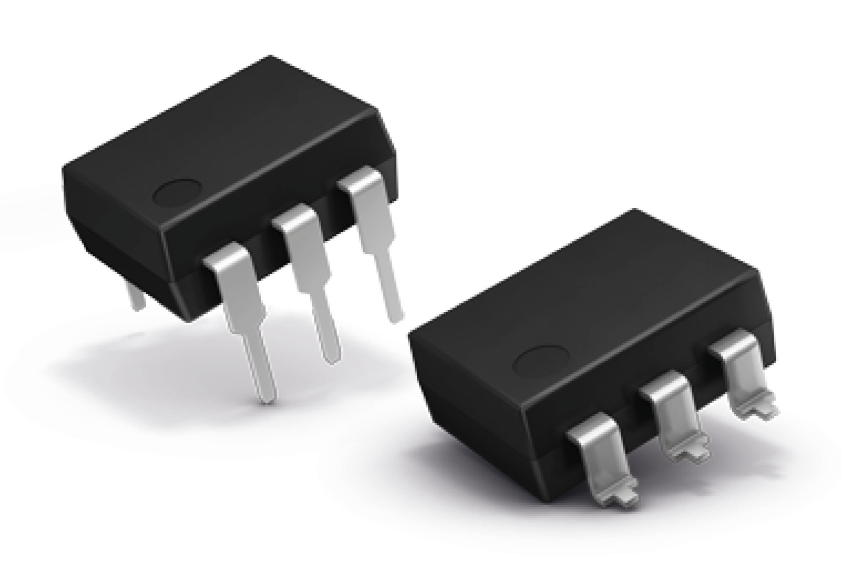
The technological progress of industrial equipment has become almost dizzyingly fast - and so have the performance demands on the necessary components.

Under these signs, the new Panasonic Industry 1FormA PhotoMOS® relay AQV209G must be considered an undisputed breakthrough in terms of high power semiconductor switching – remarkably outperforming the last generation’s specs by a 10 times higher switching capability.

By combining proven technology with next-gen materials and Galvanic isolation between input and output circuit, the semiconductor, photo-coupled relay achieves an unrivaled output rating of 1,200V at 0.75A. Continuously, with unlimited lifetime, ready for both AC and DC load.
Notwithstanding this performance increase, this latest member of the PhotoMOS® family is still coming in a small standard DIP6-pin housing, feasible by an outstanding low ON resistance of typically 1Ohm.

Based on future-proof technology, the AQV209G type is a truly interesting substitute for a lot of conventional reed relay applications or as an replacement for mercury containing types.
Ensuring quiet, fast and bounce free switching, it will be a recommended choice for a wide field of modern industrial applications, testing and measuring equipment, controls or I/O modules.

https://industry.panasonic.eu/components/relays/photomos-relays/hf-series-low-resistance

About Panasonic
Panasonic Corporation is a global leader developing innovative technologies and solutions for wide-ranging applications in the consumer electronics, housing, automotive, and B2B sectors. The company, which celebrated its 100th anniversary in 2018, operates 528 subsidiaries and 72 associated companies worldwide and reported consolidated net sales of 61.9 billion Euro (7.49 trillion yen) for the year ended March 31, 2020. Committed to pursuing new value through collaborative innovation, the company uses its technologies to create a better life and a better world for customers.
To learn more about Panasonic: http://www.panasonic.com/global

About Panasonic Industry Europe
Panasonic Industry Europe GmbH is part of the global Panasonic Group and provides automotive and industrial products and services in Europe. As a partner for the industrial sector, Panasonic researches, develops, manufactures and supplies technologies that support the slogan “A Better Life, A Better World”.
The company’s portfolio covers key electronic components, devices and modules up to complete solutions and production equipment for manufacturing lines across a broad range of industries. Panasonic Industry Europe is part of the global company Panasonic Industrial Solutions.
More about Panasonic Industry Europe: http://industry.panasonic.eu

