New micro switch with diagnostic benefits
An interesting addition to the successful ASQM micro-switch series: Panasonic Industry introduces the IP67 ASQMR switch with resistor-based detection of failure modes.
Munich, APRIL 2021
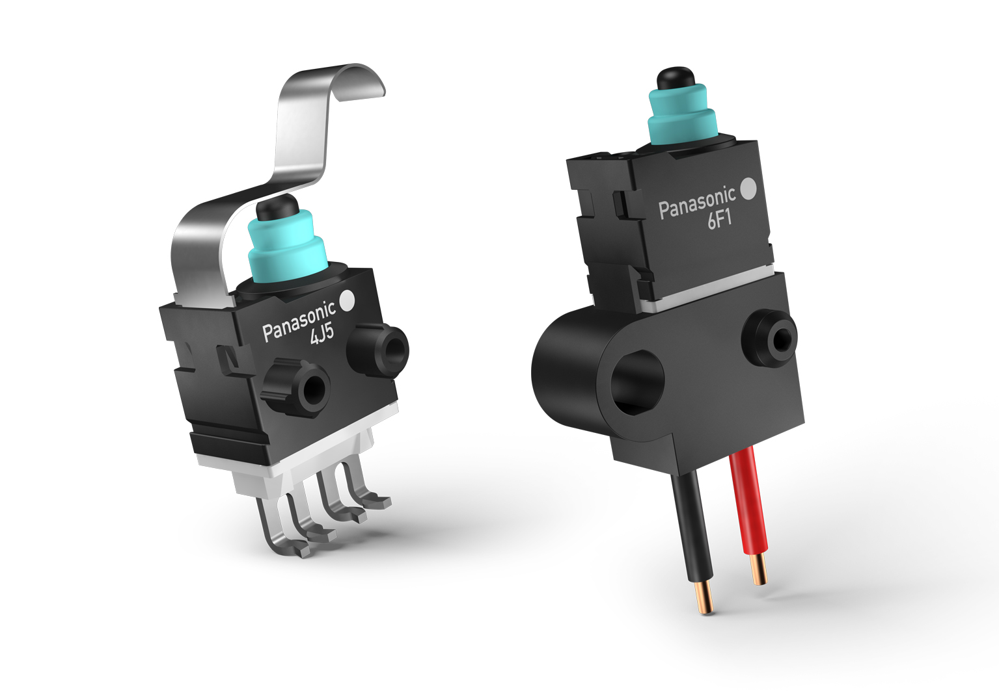
An application’s functional safety is - first and foremost - a matter of its components’ being as failure-proof as possible.

When it comes to micro switches that are a step ahead of conventional products, Panasonic Industry now has some exciting news for anyone interested in functional safety:

The new diagnostic ASQMR IP67 micro switch contains two chip resistors as voltage dividers. This feature facilitates the detection of the failure modes lead wire break or short circuits – and thus prevents the application from experiencing a serious failure or possibly causing severe damage. Setting different output voltage levels for normal vs. failure mode, the new ASQMR is the most compact resistor-equipped switch available on the market today.

Double clipping sliding contact design provides excellent shock- and vibration resistance.
For maximum freedom of choice, the product line contains solder or fork terminals as well as wire leads type. An array of levers effectively facilitates use in many applications.
From locks, latches and lids in automotive constructions to industrial emergency and safety devices or smart-home or building-automation applications – the ASQMR “mini-switch” is the component of choice for everyone seeking that extra bit of next-gen component safety and long-term reliability.

https://industry.panasonic.eu/products/components/switches/sealed-micro-switches/asqmr-diagnostic-micro-switch

About Panasonic
Panasonic Corporation is a global leader developing innovative technologies and solutions for wide-ranging applications in the consumer electronics, housing, automotive, and B2B sectors. The company, which celebrated its 100th anniversary in 2018, operates 528 subsidiaries and 72 associated companies worldwide and reported consolidated net sales of 61.9 billion Euro (7.49 trillion yen) for the year ended March 31, 2020. Committed to pursuing new value through collaborative innovation, the company uses its technologies to create a better life and a better world for customers.
To learn more about Panasonic: http://www.panasonic.com/global

About Panasonic Industry Europe
Panasonic Industry Europe GmbH is part of the global Panasonic Group and provides automotive and industrial products and services in Europe. As a partner for the industrial sector, Panasonic researches, develops, manufactures and supplies technologies that support the slogan “A Better Life, A Better World”.
The company’s portfolio covers key electronic components, devices and modules up to complete solutions and production equipment for manufacturing lines across a broad range of industries. Panasonic Industry Europe is part of the global company Panasonic Industrial Solutions.
More about Panasonic Industry Europe: http://industry.panasonic.eu

