Supporting latest standards for secure networking: The new Panasonic Industry PAN9520 Wi-Fi module

With the PAN9520, Panasonic Industry releases a new 2.4GHz 802.11b/g/n embedded Wi-Fi module providing all security features required for compliance with WPA2 and WPA3-Personal Wi-Fi security standards.

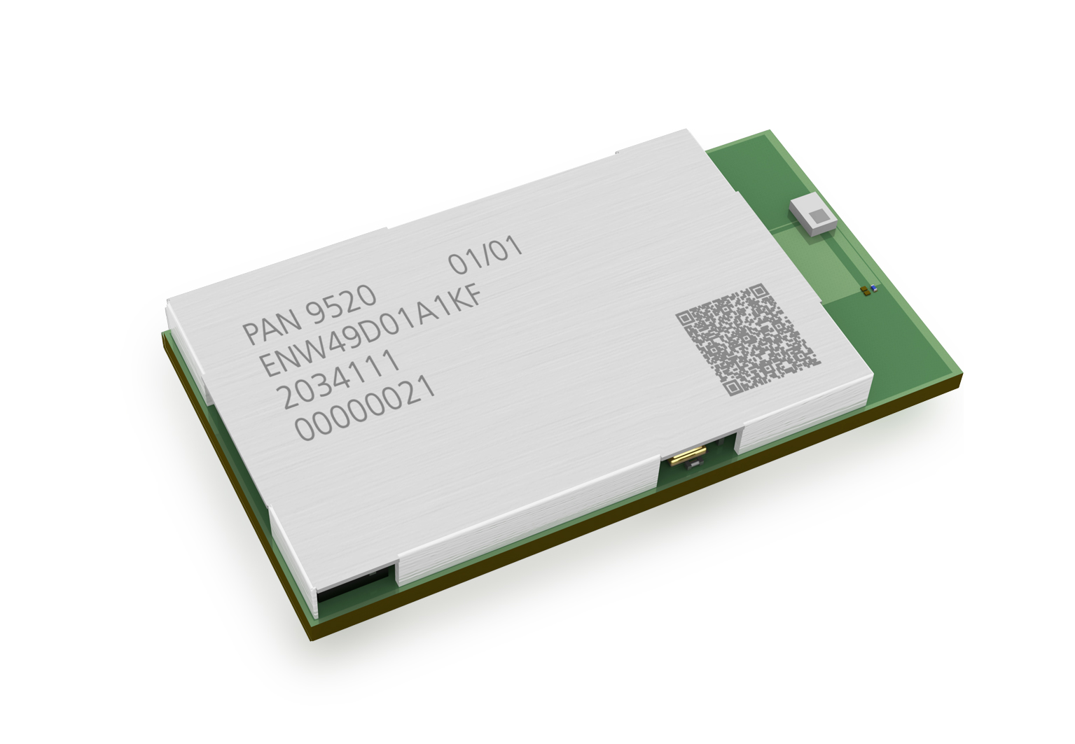
Munich, MAY 2021
The new PAN9520 is based on the Espressif ESP32-S2 microcontroller, which includes a high-performance 32-bit Xtensa® LX7 CPU, a high sensitivity wireless radio, a baseband processor, bootloader and 320kbytes of SRAM. An encryption unit supports a range of security and encryption protocols, including CCMP, TKIP, WAPI, WEP, BIP, and AES.

The integrated crystal ensures connection performance over the entire temperature range and lifetime. “Although the PAN9520 is one of the smallest modules on the market, it offers a rich set of peripherals”, says Tomislav Tipura, Wireless Connectivity Product Manager at Panasonic Industry. This set comprises full-speed USB OTG, SPI, UART, I²C and many more.

“Being a fully integrated module”, as Tipura summarizes, “the PAN9520 can be implemented quickly and easily into end-product designs - with or without a host controller.”
It includes Flash memory, a 40MHz crystal oscillator and a chip antenna. Panasonic Industry offers two variants with either 2 MB PSRAM and 4 MB Flash or no PSRAM and 1 MB Flash.

The PAN9520 supports access point mode and station mode in parallel, allowing simultaneous Wi-Fi connections to smart devices and home network routers.
Using the Espressif IoT Integrated Development Framework (ESP-IDF), engineers can develop software for a wide range of applications, and access numerous software examples which can be used to speed up development.

Learn more on the PAN9520 here.

About Panasonic
Panasonic Corporation is a global leader developing innovative technologies and solutions for wide-ranging applications in the consumer electronics, housing, automotive, and B2B sectors. The company, which celebrated its 100th anniversary in 2018, operates 528 subsidiaries and 72 associated companies worldwide and reported consolidated net sales of 61.9 billion Euro (7.49 trillion yen) for the year ended March 31, 2020. Committed to pursuing new value through collaborative innovation, the company uses its technologies to create a better life and a better world for customers.
To learn more about Panasonic: http://www.panasonic.com/global

About Panasonic Industry Europe
Panasonic Industry Europe GmbH is part of the global Panasonic Group and provides automotive and industrial products and services in Europe. As a partner for the industrial sector, Panasonic researches, develops, manufactures and supplies technologies that support the slogan “A Better Life, A Better World”.
The company’s portfolio covers key electronic components, devices and modules up to complete solutions and production equipment for manufacturing lines across a broad range of industries. Panasonic Industry Europe is part of the global company Panasonic Industrial Solutions.
More about Panasonic Industry Europe: http://industry.panasonic.eu

