Choose the force you need: new high-power Photovoltaic MOSFET drivers
Panasonic Industry adds high-current or high-voltage output models to its lineup of APV series Photovoltaic MOSFET drivers

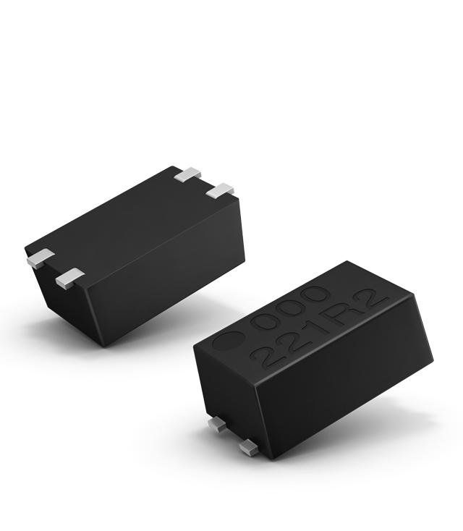
Munich, JUNE 2021
Modern industrial automation solutions, energy systems and professional equipment are often extremely specialized devices that require high safety and design flexibility for switching elements like semiconductor relays. A photovoltaic driver for galvanic separation in combination with a distinct MOSFET power switch leaves nothing to be desired.

The new APV models of Panasonic Industry’s Photovoltaic MOSFET drivers can control MOSFETS in a new range by offering high-output voltage or high-output current.
The Photovoltaic MOSFET drivers come in a miniaturized SSOP housing and provide a galvanic separation of 1,500V between the control circuit and the power output circuit. The new high-power type APV3111GVY directly switches Power MOSFETs for high-load currents, thanks to a generated output voltage of 18V used for controlling the MOSFETs Gates, a feature that reduces the number of amplifier parts on the PCB.
,
APV1111GVY comes into play in the context of high-speed switching with high-current requirements - and stands out with a remarkable output current of 45μA for fast MOSFET Gate charging.
It is a straightforward driver principle, one that is ready for efficient and miniaturized next-gen high-power applications in a wide range of temperatures, including power supply devices, measuring equipment, energy storage systems and much more.
Learn more about the choice of power offered by the APV series.

About Panasonic
Panasonic Corporation is a global leader developing innovative technologies and solutions for wide-ranging applications in the consumer electronics, housing, automotive, and B2B sectors. The company, which celebrated its 100th anniversary in 2018, operates 528 subsidiaries and 72 associated companies worldwide and reported consolidated net sales of 61.9 billion Euro (7.49 trillion yen) for the year ended March 31, 2020. Committed to pursuing new value through collaborative innovation, the company uses its technologies to create a better life and a better world for customers.
To learn more about Panasonic: http://www.panasonic.com/global

About Panasonic Industry Europe
Panasonic Industry Europe GmbH is part of the global Panasonic Group and provides automotive and industrial products and services in Europe. As a partner for the industrial sector, Panasonic researches, develops, manufactures and supplies technologies that support the slogan “A Better Life, A Better World”.
The company’s portfolio covers key electronic components, devices and modules up to complete solutions and production equipment for manufacturing lines across a broad range of industries. Panasonic Industry Europe is part of the global company Panasonic Industrial Solutions.
More about Panasonic Industry Europe: http://industry.panasonic.eu

