Avoiding fatal contact failures in electronic components: Insights on red phosphorous flame retardants.
During the recent ICEC conference, Panasonic Industry’s component researchers addressed solutions to overcome contact resistances caused by phosphorous outgassing. For everyone who is interested, there is now a comprehensive whitepaper to download for free.
Munich, JUNE 2021
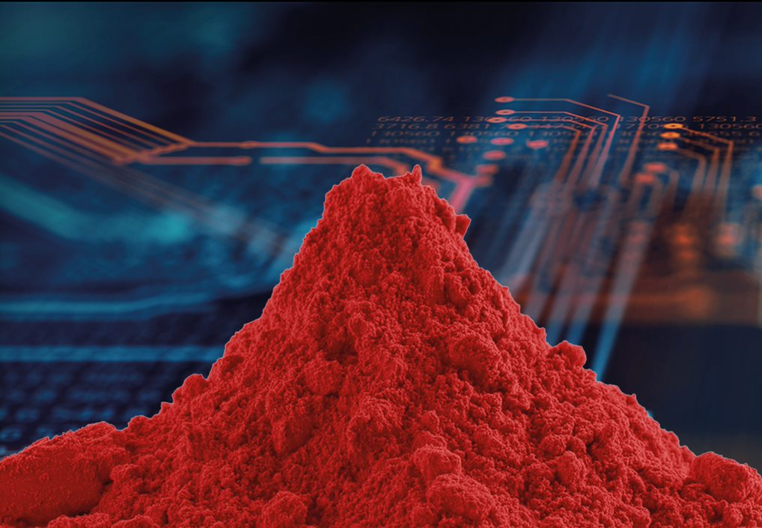
The challenge: In plastic materials that are flame retardant with red phosphorous, outgassing can occur.
This has an impact on electronic components – in relays, for example, it can cause increased contact resistance, and some corrosion phenomena of components on printed circuit board assemblies (PCBAs) can also be traced back to red phosphorous. In both the outgassing itself and the corrosion process, humidity plays a crucial role. In certain environmental conditions, it leads to the formation of different phosphorous acids and gaseous phosphine.
The solution: During their June 2021 presentation at the 2020 International Conference on Electrical Contacts (ICEC), Dr. Dieter Volm and Dr. Thomas Herrle spoke about the influence of plastics containing red phosphorous on electronic components and relays and shared their research of the influence of three differently flame-retarded polyamide (PA) choke coil bobbins on the contact resistances of a nearby unsealed relay.
This illustrated fundamental component design-in insights to overcome contact failures and increase the reliability and lifetime of applications using relays.
For anyone who missed the presentation during the conference – or is interested in learning more details about this topic, a comprehensive whitepaper from the Panasonic Industry experts is available free of charge here.

About Panasonic
Panasonic Corporation is a global leader developing innovative technologies and solutions for wide-ranging applications in the consumer electronics, housing, automotive, and B2B sectors. The company, which celebrated its 100th anniversary in 2018, operates 522 subsidiaries and 69 associated companies worldwide and reported consolidated net sales of Euro 54.02 billion (6,698.8 billion yen) for the year ended March 31, 2021. Committed to pursuing new value through collaborative innovation, the company uses its technologies to create a better life and a better world for customers. Learn more about Panasonic: https://www.panasonic.com/global
.
About Panasonic Industry Europe
Panasonic Industry Europe GmbH is part of the global Panasonic Group and provides automotive and industrial products and services in Europe. As a partner for the industrial sector, Panasonic researches, develops, manufactures and supplies technologies that support the slogan “A Better Life, A Better World”.
The company’s portfolio covers key electronic components, devices and modules up to complete solutions and production equipment for manufacturing lines across a broad range of industries. Panasonic Industry Europe is part of the global company Panasonic Industrial Solutions.
More about Panasonic Industry Europe: http://industry.panasonic.eu

