Allez: Panasonic employees run & cycle for a good cause
5000 € raised for Munich inclusive fencing club – handing over ceremony at Panasonic Campus Munich
Munich, SEPTEMBER 2021
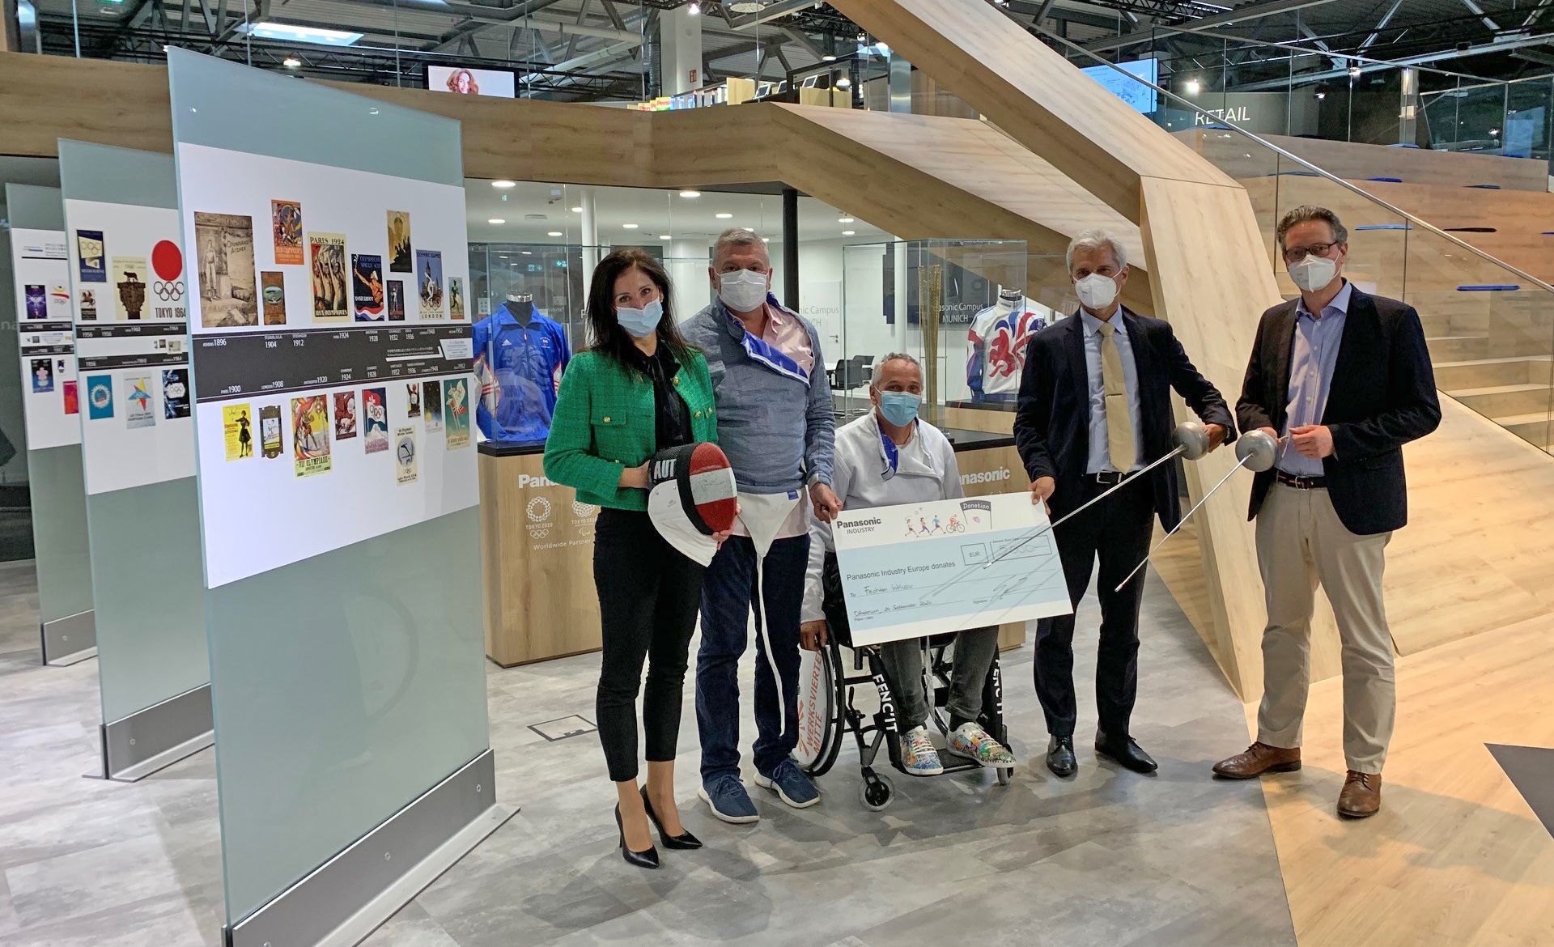
A few days ago, just in the aftermath of the Paralympic Games in Tokyo, Panasonic Industry’s President Johannes Spatz and CHRO Ralf zur Steege handed over a donation cheque in the amount of € 5,000.- to Jürgen Zielinski-Lick, Chairman of the Fechten Inklusiv fencing club from Munich, and Didier Junk, a wheelchair fencer.
Staff running and cycling for a good cause
The money has been raised from the internal Run & Cycle for a Good Cause Charity project at Panasonic Industry in Ottobrunn, Germany.
All employees have been encouraged to collect cycling and running kilometers to be reimbursed by the company for a good cause.
“It is my great pleasure to support the Paralympic idea and the wheelchair fencer from the Fechten Inklusiv fencing club. I am proud of all the kilometers our employees ran and cycled for this good cause,” said President Johannes Spatz while handing over the cheque to gratefully delighted Jürgen Zielinski-Lick:
“I am overwhelmed by this generous gift and would like to express my sincere appreciation, also in the name of my athletes. Please know that with this valuable donation, you will support our wheelchair fencers this World Cup season, which is the first step towards the 2024 Paris Paralympic qualification. Thank you and keep your fingers crossed for our Paralympic fencers,” he said.
​​​The story behind
The Fechten Inklusiv fencing club was founded five years ago by Zielinski-Lick after he lost during a tournament to a wheelchair fencer. Consequently, he did some research and realized that there was no wheelchair fencing club in Munich at that time. Zielinski-Lick bought a few metal bars in the hardware store, welded them into a frame on which the wheelchairs could be fixed and started looking for members. He also acquired fencers without impairment to support his idea. Today, the Fechten Inklusiv fencing club is proud to have seven wheelchair fencers, four honorary coaches and one honorary massage therapist. Several fencers without impairment participate in the training sessions to support the Paralympic idea and to get challenged.
Learn more on the idea and the great people behind Fechten Inklusiv.

About Panasonic
Panasonic Corporation is a global leader developing innovative technologies and solutions for wide-ranging applications in the consumer electronics, housing, automotive, and B2B sectors. The company, which celebrated its 100th anniversary in 2018, operates 522 subsidiaries and 69 associated companies worldwide and reported consolidated net sales of Euro 54.02 billion (6,698.8 billion yen) for the year ended March 31, 2021. Committed to pursuing new value through collaborative innovation, the company uses its technologies to create a better life and a better world for customers. Learn more about Panasonic: https://www.panasonic.com/global
.
About Panasonic Industry Europe
Panasonic Industry Europe GmbH is part of the global Panasonic Group and provides automotive and industrial products and services in Europe. As a partner for the industrial sector, Panasonic researches, develops, manufactures and supplies technologies that support the slogan “A Better Life, A Better World”.
The company’s portfolio covers key electronic components, devices and modules up to complete solutions and production equipment for manufacturing lines across a broad range of industries. Panasonic Industry Europe is part of the global company Panasonic Industrial Solutions.
More about Panasonic Industry Europe: http://industry.panasonic.eu

