High data rates, low-power operation: New dual-band Wi-Fi 5 and Bluetooth® 5 module PAN9028 guarantees maximum flexible connectivity
Following the market’s high demand for modules suiting highly integrated applications and rapid certification processes, Panasonic Industry now presents the PAN9028 Wi-Fi® radio module with integrated Bluetooth® wireless functionality.
Munich, SEPTEMBER 2021
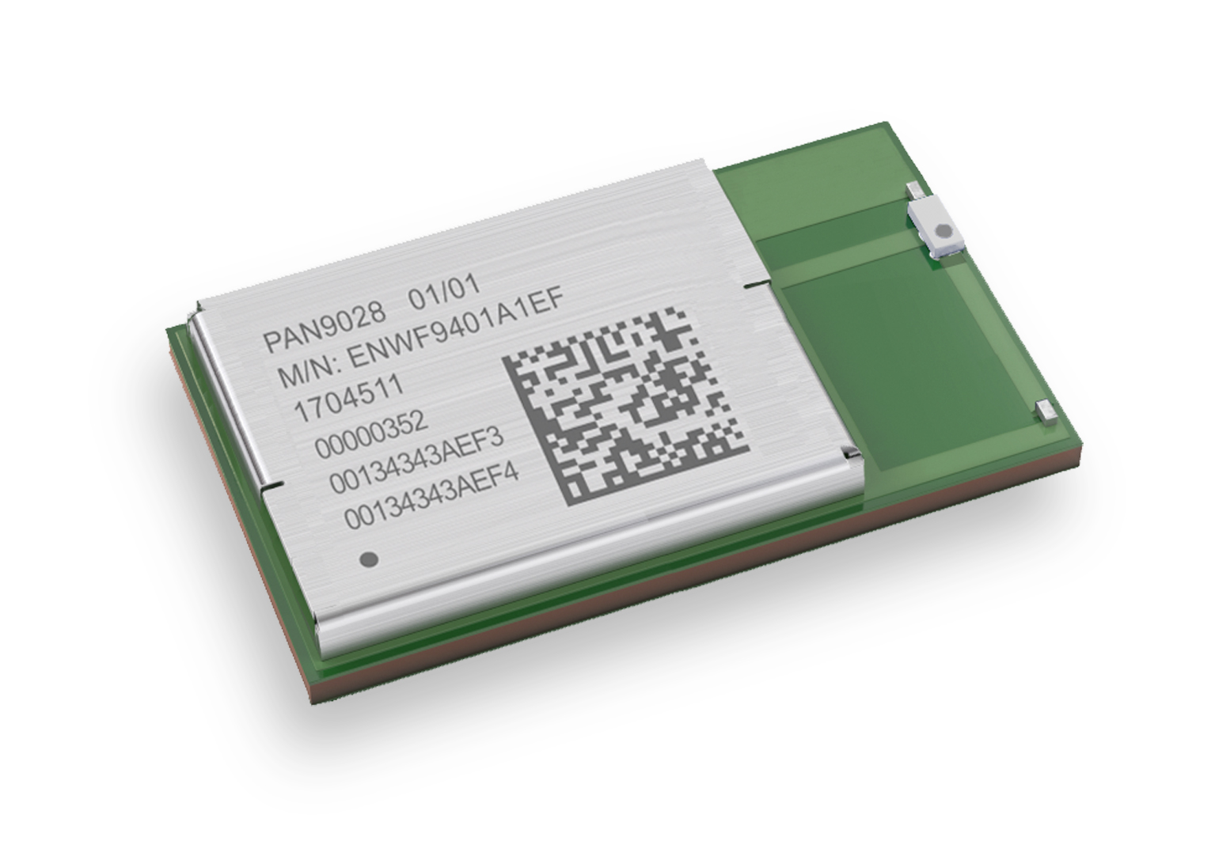
Nowadays, the fast-paced product development cycles in almost any field of applications require designers to resort to efficient solutions that enable quicker prototyping, shortened certification processes – and a reasonable BOM.
Specifically for those highly-integrated and cost-effective applications, Panasonic Industry now introduces the PAN9028, a dual band 2.4 GHz and 5 GHz 802.11 a/b/g/n/ac Wi-Fi radio module with integrated Bluetooth® BR/EDR/Low Energy wireless functionality, based on the NXP Semiconductors 88W8987 wireless chipset.
“The 802.11ac capable, simultaneous and independent operation of the two standards enables high data throughput and low-power operation”, summarizes Tomislav Tipura from Panasonic Industry Europe in Ottobrunn, Germany. The PAN9028 supports download data rates of up to 433 Mbit/s – and optionally includes a power management IC, which allows simpler hardware design and reducing BOM costs. Tx power calibration data, Wi-Fi, and Bluetooth® system parameters for CE RED, FCC and ISED regions are pre-stored on the module’s one-time-programmable memory during production, which means that only one part number is needed for the three different regions.
In terms of security, the PAN9028 complies with the IEEE 802.11i standard and comprises AES cryptography, CCMP as well as other established mechanisms.
Reliable performance and quality, speed and safety: For anyone interested in minimizing design, testing, calibration and certification efforts, the PAN9028 module might be the key to achieve a faster time to market.
Learn more on the brand new PAN9028 module and its technical specifications here

About Panasonic
Panasonic Corporation is a global leader developing innovative technologies and solutions for wide-ranging applications in the consumer electronics, housing, automotive, and B2B sectors. The company, which celebrated its 100th anniversary in 2018, operates 522 subsidiaries and 69 associated companies worldwide and reported consolidated net sales of Euro 54.02 billion (6,698.8 billion yen) for the year ended March 31, 2021. Committed to pursuing new value through collaborative innovation, the company uses its technologies to create a better life and a better world for customers. Learn more about Panasonic: https://www.panasonic.com/global
.
About Panasonic Industry Europe
Panasonic Industry Europe GmbH is part of the global Panasonic Group and provides automotive and industrial products and services in Europe. As a partner for the industrial sector, Panasonic researches, develops, manufactures and supplies technologies that support the slogan “A Better Life, A Better World”.
The company’s portfolio covers key electronic components, devices and modules up to complete solutions and production equipment for manufacturing lines across a broad range of industries. Panasonic Industry Europe is part of the global company Panasonic Industrial Solutions.
More about Panasonic Industry Europe: http://industry.panasonic.eu

