Proven technology, phenomenal increase in lifetime and ready for the heat
Panasonic Industry enters new era by extending SP-Cap Polymer Capacitor line-up with temperature resistant KX series - 5,500 hours at 125°C
Munich, March 2022
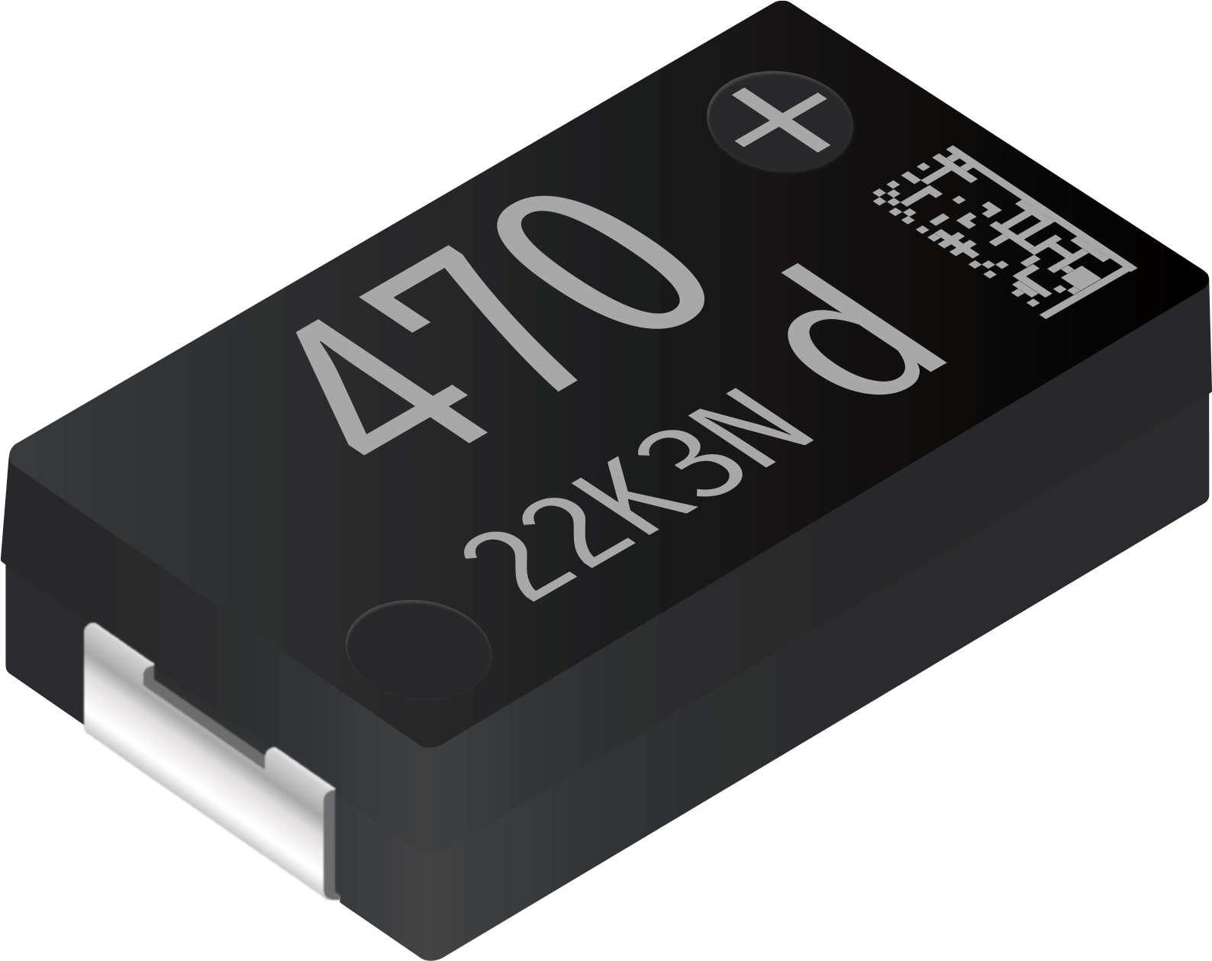
Panasonic Industry’s SP-Cap portfolio of Aluminum Polymer capacitors is the ideal choice wherever a low ESR would be the primary consideration for identifying the most suitable capacitor.

Panasonic’s advanced Solid Polymer technology, the SP-Caps have proven to be an excellent alternative to multilayer ceramic capacitors (MLCCs) and pure tantalum capacitors. They require less parts and space on the PCB and provide much better performance, especially for modern and complex low-profile electronical devices, with large capacitance up to 820 µF and a ripple current up to 10.2 Arms.

Panasonic Industry has expanded the successful technology further with the new KX series – a very high endurance and particularly heat tolerant series.
Coming with the typically low ESR of 9mohm, a large capacitance, a low profile, long life span and high characteristic stability, this latest member of the SP-Cap family stands out with an endurance of 5,500 hours at 125°C and thus promises an outstanding reliability. It’s remarkable damp heat specifications – 1,000 hours at 85°C 85%RH – similar to JX series, render it suitable for demanding outdoor applications. Shahrokh Kananizadeh, Product Manager at Panasonic Industry, is well aware that there are a lot of them: “The KX series has many benefits in a wide range of applications, such as noise reduction or voltage smoothing in base stations, networks, servers, accelerators and industrial equipment. Briefly said, the KX series sets new standards in terms of high temperature reliability – and underlines the superiority of polymer technology for new designs.”

Learn more on new KX series' specs on our product finder pages.

About Panasonic
Panasonic Corporation is a global leader developing innovative technologies and solutions for wide-ranging applications in the consumer electronics, housing, automotive, and B2B sectors. The company, which celebrated its 100th anniversary in 2018, operates 522 subsidiaries and 69 associated companies worldwide and reported consolidated net sales of Euro 54.02 billion (6,698.8 billion yen) for the year ended March 31, 2021. Committed to pursuing new value through collaborative innovation, the company uses its technologies to create a better life and a better world for customers. Learn more about Panasonic: https://www.panasonic.com/global
.
About Panasonic Industry Europe
Panasonic Industry Europe GmbH is part of the global Panasonic Group and provides automotive and industrial products and services in Europe. As a partner for the industrial sector, Panasonic researches, develops, manufactures and supplies technologies that support the slogan “A Better Life, A Better World”.
The company’s portfolio covers key electronic components, devices and modules up to complete solutions and production equipment for manufacturing lines across a broad range of industries. Panasonic Industry Europe is part of the global company Panasonic Industrial Solutions.
More about Panasonic Industry Europe: http://industry.panasonic.eu

