Proven performance - and ready for a more flexible transmission: New antenna-less PAN1316C
For applications with RF unfriendly housings, Panasonic Industry now launches new dual-mode PAN1316C module being an antenna-less variant of the PAN1326C2.
Munich, JUNE 2022
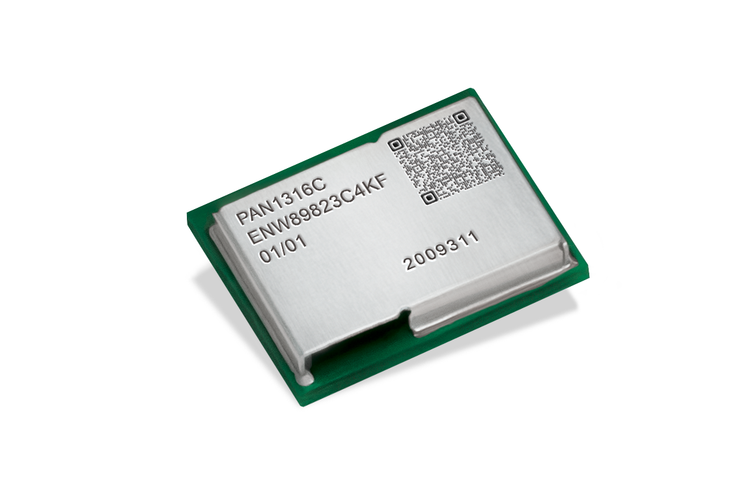
A modern device’s housing is supposed to fulfil several criteria at the same time: Being compact and, for instance, rugged or waterproof at the same time might lead to the undesirable consequence of radio waves hitting an impermeable housing structure.
With the new PAN1316C, Panasonic Industry has now tackled this particular issue und succeeded in offering a solution to circumvent a housing’s apparent RF unfriendliness:

The dual-mode PAN1316C, supporting Bluetooth® Low Energy and Bluetooth® Classic is ready for the connection of an external antenna via bottom pin, but – as its “sibling” - comes with all the PAN1326C2’s convincing specs as Host Controlled Interface (HCI) Bluetooth® Radio Frequency (RF) module.

“We are happy that we have been able to elimininate some developers’ headaches with the PAN1316C”, comments Tomislav Tipura from Panasonic Industry Europe, “and that this outstanding technology is now also available for applications with housings that are anything but ready for radio waves.”

With a a tiny footprint of only 58,5mm² (9 0mm × 6.5mm ×1.8mm and coming with the CC2564C, Texas Instruments™ seventh generation Bluetooth® core integrated circuit, it offers best-in-class performance - about twice the range of other Bluetooth® Low Energy solutions.

Next to the UART interface, the module contains a audio/voice codec interface which is a fully-dedicated programmable serial port that provides the logic to interface to several kinds of PCM or I2S codec’s. The wide operating temperature range is -40°C up to +85°C and the supply voltage range is 1.8V up to 4.8V.

Particularly convenient: The PAN1316C is even 100 % pin-compatible with previous generations of Texas Instruments-based Bluetooth HCI modules.

Learn more on our latest member from the Panasonic Industry module famliy on our web page.

About the Panasonic Group
A global leader in developing innovative technologies and solutions for wide-ranging applications in the consumer electronics, housing, automotive, industry, communications, and energy sectors worldwide, the Panasonic Group switched to an operating company system on April 1, 2022 with Panasonic Holdings Corporation serving as a holding company and eight companies positioned under its umbrella. Founded in 1918, the Group is committed to enhancing the well-being of people and society and conducts its businesses based on founding principles applied to generate new value and offer sustainable solutions for today’s world. The Group reported consolidated net sales of Euro 56.40 billion (7,388.8 billion yen) for the year ended March 31, 2022. Devoted to improving the well-being of people, the Panasonic Group is united in providing superior products and services to help you Live Your Best.
To learn more about the Panasonic Group, please visit: https://holdings.panasonic/global/

About Panasonic Industry Europe
Panasonic Industry Europe GmbH is part of the global Panasonic Group and provides automotive and industrial products and services in Europe.
The company’s portfolio covers key electronic components, devices and modules up to complete solutions and production equipment for manufacturing lines across a broad range of industries.
More about Panasonic Industry Europe: http://industry.panasonic.eu

