Excellently average
New 100V load voltage type relevantly complements Panasonic Industry’s popular General Use (GU) series of PhotoMOS® relays
Munich, JUNE 2022
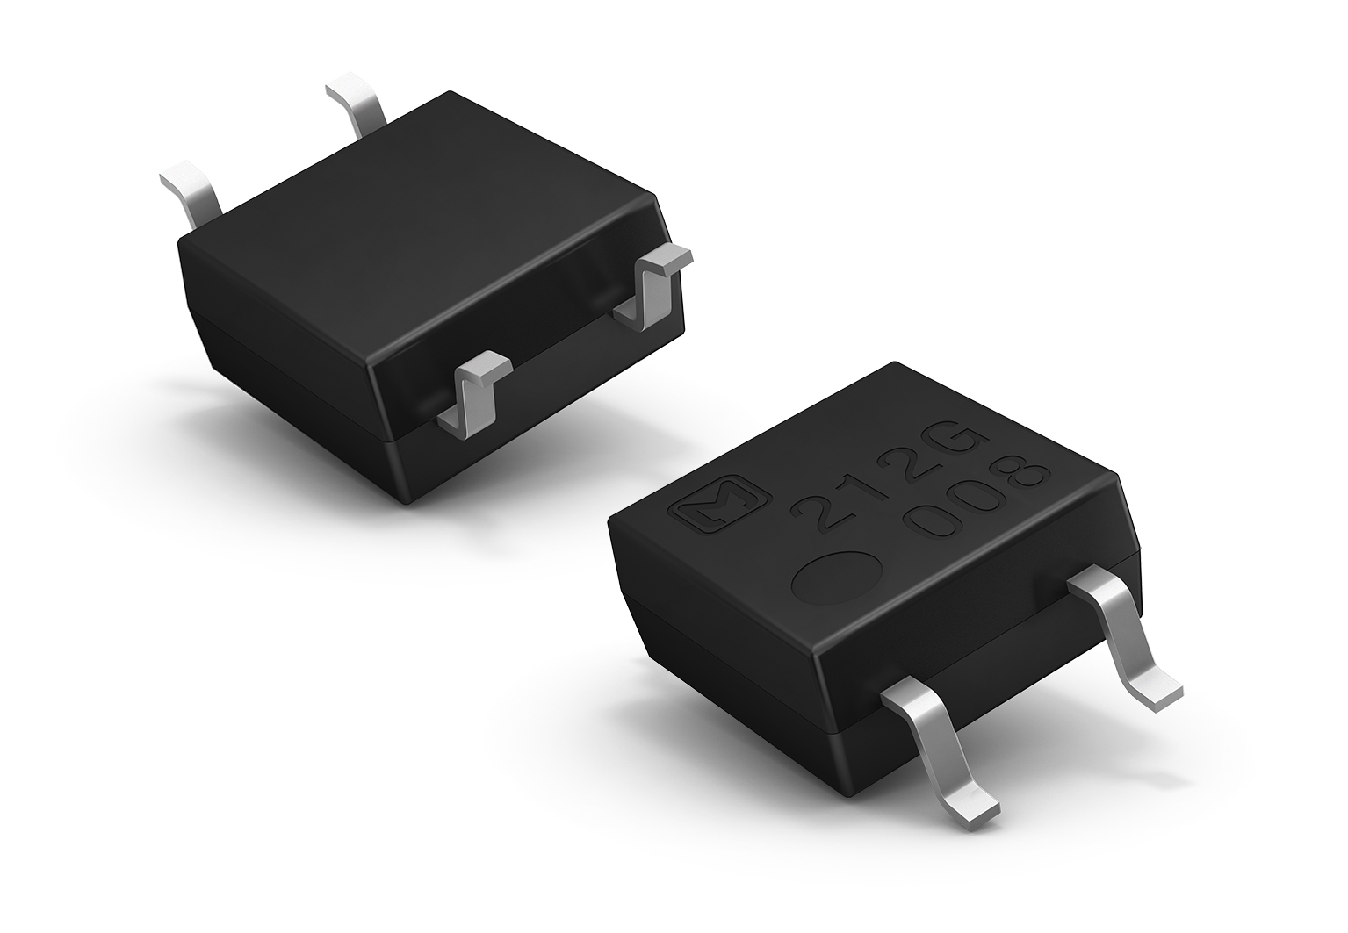
Sometimes it is not the superlative performance features that make a product launch particularly interesting, but its sheer relevance for many markets: With the new AQY215S 100V load voltage type, Panasonic Industry complements its GU series of MOSFET relays in the middle of the feature scale.

Coming in a compact SOP 4-pin package just as its 60V, 350V and 400V siblings, the new 100V type is expected to be an ideal choice for a wide range of robotics applications, PLCs. I/O modules, testing or measuring equipment.
“The name General Use series speaks for itself. With its low-level off state leakage current of max. 1μA, the small package size and its proven reliability and efficiency, we are now more than happy to add a new model to our successful GU family of ‘PhotoMOS® allrounders’”, as Michael Renner from Panasonic Industry gets it to the point.
“Average, but excellent.”

Learn more on the new 100V Type and our entire GU series on our Website.

About Panasonic Industry Europe
Panasonic Industry Europe GmbH is part of the global Panasonic Group and provides automotive and industrial devices, key electronic components, and comprehensive services in Europe.
Panasonic Industry’s portfolio covers next-gen components, devices and modules up to complete solutions and production equipment for manufacturing lines across a broad range of industries.
More about Panasonic Industry Europe: http://industry.panasonic.eu

About the Panasonic Group
A global leader in developing innovative technologies and solutions for wide-ranging applications in the consumer electronics, housing, automotive, industry, communications, and energy sectors worldwide, the Panasonic Group switched to an operating company system on April 1, 2022, with Panasonic Holdings Corporation serving as a holding company and eight companies positioned under its umbrella. Founded in 1918, the Group is committed to enhancing the well-being of people and society and conducts its businesses based on founding principles applied to generate new value and offer sustainable solutions for today’s world. The Group reported consolidated net sales of Euro 56.40 billion (7,388.8 billion yen) for the year ended March 31, 2022. Devoted to improving the well-being of people, the Panasonic Group is united in providing superior products and services to help you Live Your Best.
To learn more about the Panasonic Group, please visit: https://holdings.panasonic/global/

