New 1500V PhotoMOS® relay in miniature DIP5 package from Panasonic targets industrial BMS
Delivers increased creepage & clearance, stable on-resistance over lifetime, and unlimited switching cycles
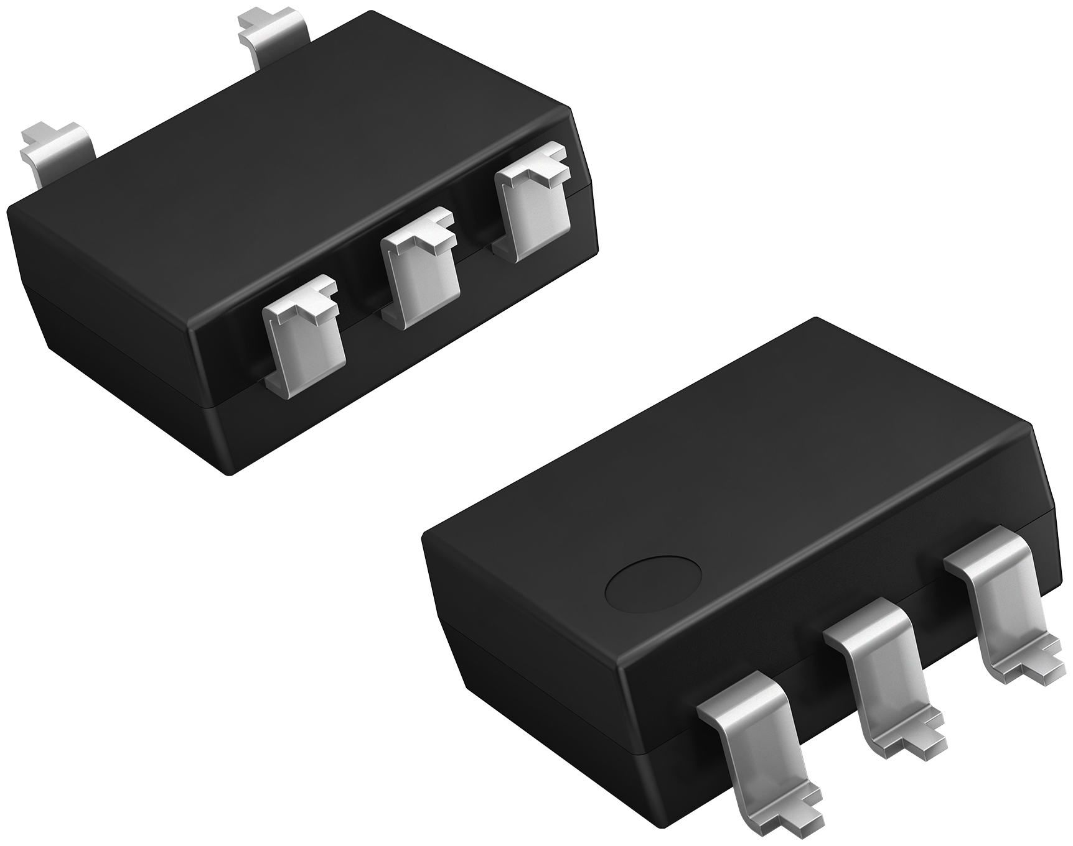
Munich, September 2022
The new PhotoMOS® HE relay series from Panasonic Industry Europe offers 5kV I/O isolation and an increased clearance and creepage distance on output side, plus miniature 1-Form-A DIP5 packaging, making it particularly suitable as the switching solution for Battery Management Systems (BMS) in storage systems, charging stations, and numerous other high voltage measurement and infrastructure control applications.

”Industrial BMS applications demand reliability and consistent performance over the product lifespan”, says Michael Renner, Product Manager at Panasonic Industry Europe. “These new devices extend the load voltage of Panasonic’s PhotoMOS® relay family and improve ruggedness and stability.”

Rated at 1,500V/20mA, new AQV258H5 HE series PhotoMOS® relays have a MOSFET output and enjoy an almost unlimited lifetime if used according to the specifications. On-resistance remains stable throughout the entire lifetime – and AQV258H5 HE series PhotoMOS® relays – unlike electromechanical devices - are unaffected by vibration, a significant benefit in many industrial applications.

New PhotoMOS® series AQV258H5 relays also feature a low control current and low leakage current and produce no switching noise. Devices come with 5 pins to accomodate different creepage and clearance requirements, but a 6 pin version is also available.Both types are offered with through-hole or surface-mount terminations.

Learn more on Panasonic Industry’s PhotoMOS® HE series on our web page.

About the Panasonic Group
A global leader in developing innovative technologies and solutions for wide-ranging applications in the consumer electronics, housing, automotive, industry, communications, and energy sectors worldwide, the Panasonic Group switched to an operating company system on April 1, 2022 with Panasonic Holdings Corporation serving as a holding company and eight companies positioned under its umbrella. Founded in 1918, the Group is committed to enhancing the well-being of people and society and conducts its businesses based on founding principles applied to generate new value and offer sustainable solutions for today’s world. The Group reported consolidated net sales of Euro 56.40 billion (7,388.8 billion yen) for the year ended March 31, 2022. Devoted to improving the well-being of people, the Panasonic Group is united in providing superior products and services to help you Live Your Best.
To learn more about the Panasonic Group, please visit: https://holdings.panasonic/global/

About Panasonic Industry Europe
Panasonic Industry Europe GmbH is part of the global Panasonic Group and provides automotive and industrial products and services in Europe.
The company’s portfolio covers key electronic components, devices and modules up to complete solutions and production equipment for manufacturing lines across a broad range of industries.
More about Panasonic Industry Europe: http://industry.panasonic.eu

