Ready for your ideas – and available on short lead times: Panasonic Industry’s range of BLE modules
Following Panasonic’s massive investments in stock, PAN1780, PAN1770, PAN1781 and PAN1782 Bluetooth® Low Energy modules are available within 14-16 weeks.

Munich, October 2022
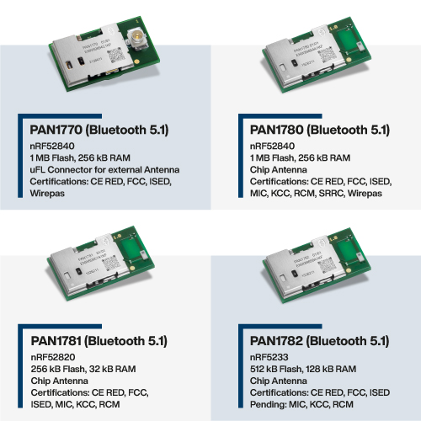
Despite the tense situation on the semiconductor markets for the past two years, Panasonic Industry has invested heavily in stocks - and now reports that, for instance, the Bluetooth® Low Energy modules from the PAN1780 family are available in exeptionally short lead times now.

“A lead time as short as approximately 16 weeks for a comprehensive range of top-notch BLE modules should be considered unrivalled at the moment”, comments Tomislav Tipura from Panasonic’s Wireless Connectivity department.

The company’s range of Nordic Semiconductor-based BLE wireless modules comprises the flagship PAN1780 as well as it’s siblings PAN1770, PAN1781 and PAN1782. Each of them is coming with tailored specs and a well thought-out price-performance ratio – meeting the most relevant application requirements:

PAN1780 is a Bluetooth® 5 Low Energy Module based on the Nordic nRF52840 single-chip controller coming with 1MB Flash/256kB RAM and integrated chip antenna

PAN1770 is the antenna-less sibling of PAN1780 – and provides an uFL connector for applications with radio-unfriendly housings

PAN1781 comes with the nRF52820 single-chip controller inside – and renders with its 256kB Flash/32kB RAM an ideally cost-effective solution for compact applications.

PAN1782 is the latest member in Panasonic’s BLE module family – and with 512 kB Flash/128 kB RAM memory the perfect trade-off between performance and price.

“We know there are people with great application projects out there, but rapid implementation often fails due to unavailable components”, concludes Tipura. “So, at least when it comes to delivering the proven BLE module of choice, we’re as fast as your ideas.”

Get in touch with wireless.connectivity@eu.panasonic.com
– or approach your local distributor for more information.

Visit our website to learn more about Panasonic’s range of Wireless products

About the Panasonic Group
A global leader in developing innovative technologies and solutions for wide-ranging applications in the consumer electronics, housing, automotive, industry, communications, and energy sectors worldwide, the Panasonic Group switched to an operating company system on April 1, 2022 with Panasonic Holdings Corporation serving as a holding company and eight companies positioned under its umbrella. Founded in 1918, the Group is committed to enhancing the well-being of people and society and conducts its businesses based on founding principles applied to generate new value and offer sustainable solutions for today’s world. The Group reported consolidated net sales of Euro 56.40 billion (7,388.8 billion yen) for the year ended March 31, 2022. Devoted to improving the well-being of people, the Panasonic Group is united in providing superior products and services to help you Live Your Best.
To learn more about the Panasonic Group, please visit: https://holdings.panasonic/global/

About Panasonic Industry Europe
Panasonic Industry Europe GmbH is part of the global Panasonic Group and provides automotive and industrial products and services in Europe.
The company’s portfolio covers key electronic components, devices and modules up to complete solutions and production equipment for manufacturing lines across a broad range of industries.
More about Panasonic Industry Europe: http://industry.panasonic.eu

