Low noise and vibration: Panasonic presents two new cordless mechanical-pulse wrenches
The two new 10.8V EYFLF1 and EYFLF2 improve the professional working environment
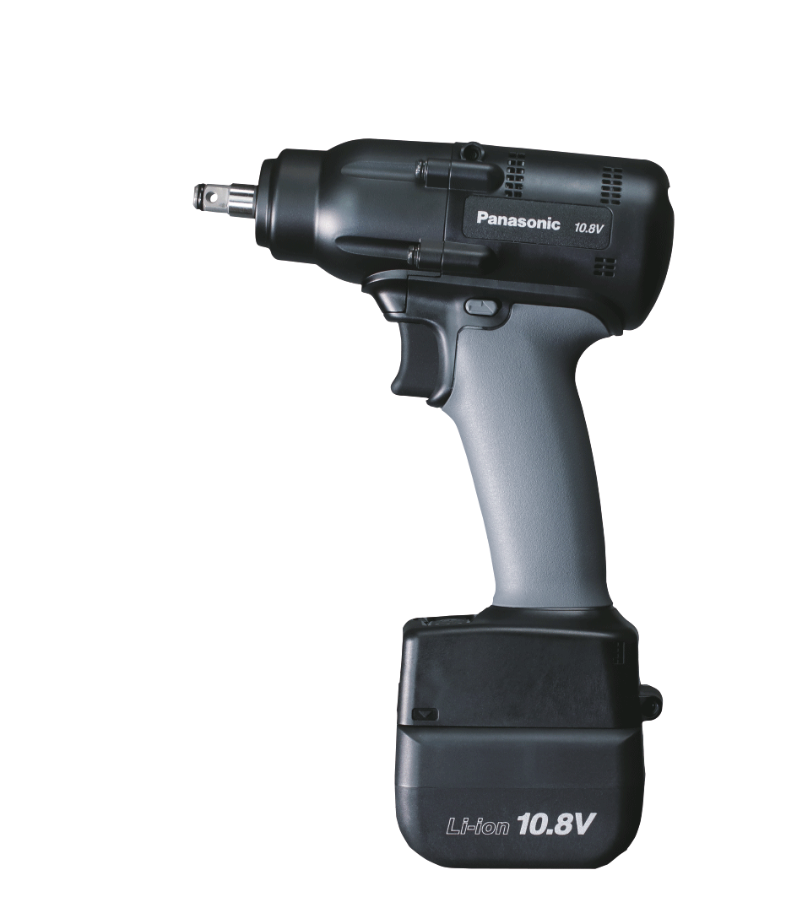
Munich, March 2023
Not one but two new mechanical-pulse (M-P) wrenches are being introduced by Panasonic Power Tools Europe: the EYFLF1 and EYFLF2 both feature a new mechanical pulse structure with a highly durable split anvil shaft and an enlarged metal hammer.
This results in a reduction of pulse noise and reduced vibration due to lower pulse frequency – up to 10db less noise and approximately 75% less vibration compared to the previous model EYFLA5.
The main difference between the two new models is their torque range: EYFLF1 features a torque shut-off range between 3 – 20 Nm, EYFLF2 ranges from 6- 35 Nm.

“The two new M-P wrenches provide more comfort for professionals and the professional working environment. Besides the reduction of noise and vibration, also the overheating risk was reduced. Both wrenches use the new mechanical pulse structure, which limits the risk of overheating in serial fastening applications”, says Kunihiko Nedachi, Head of Power Tools Europe. “Ultimately, this results in an increase in productivity, because more work per battery charge can be achieved.”

Compact, lightweight and kinder to the environment
The EYEFLF1 and EYEFLF2 only weigh about 1.3Kg to 1.45Kg (incl. battery) and measure 167 x 249 x 59mm. One of the convenient features of the M-P wrenches is the slow rotation start at 200 Rpm, which prevents accidental cross-threading while fastening.
In contrast to conventional oil pulse-driven wrenches, the new mechanical pulse structure is maintenance-free and ultimately reduces the running costs of the power tool. Besides that, a cordless wrench uses less energy compared to pneumatic wrenches, so the EYEFLF1 and EYEFLF2 are kinder to the environment.

For further information on the latest member of Panasonic’s Power Tool family, visit the world of Panasonic Power Tools.

About the Panasonic Group
A global leader in developing innovative technologies and solutions for wide-ranging applications in the consumer electronics, housing, automotive, industry, communications, and energy sectors worldwide, the Panasonic Group switched to an operating company system on April 1, 2022 with Panasonic Holdings Corporation serving as a holding company and eight companies positioned under its umbrella. Founded in 1918, the Group is committed to enhancing the well-being of people and society and conducts its businesses based on founding principles applied to generate new value and offer sustainable solutions for today’s world. The Group reported consolidated net sales of Euro 56.40 billion (7,388.8 billion yen) for the year ended March 31, 2022. Devoted to improving the well-being of people, the Panasonic Group is united in providing superior products and services to help you Live Your Best.
To learn more about the Panasonic Group, please visit: https://holdings.panasonic/global/

